**Lance Baker’s Personal journal**

**Entry 1, 1st of Fall, 5500**

**29 days after initial arrival**

Although I arrived five days after the initial group, I feel like I’ve been here from beginning. Saburo Hood has stepped down as our leader, and it’s my turn to take the lead. Coming in, we have a wonderful colony already. Each of us have our own one room buildings, and abundant supplies, I feel it’s time do something with these supplies. My first order of business is to designate some new farm land for our growing population.

As morning came around, everyone hurried off to work for our new plans for a better colony. During the evening hours, a bright light filled the sky around our growing settlement, I feared pirates arriving from the sky; however, my fears where soon settled as a small chuck of space debris landed inside our walls. Free components and steel are always appreciated.

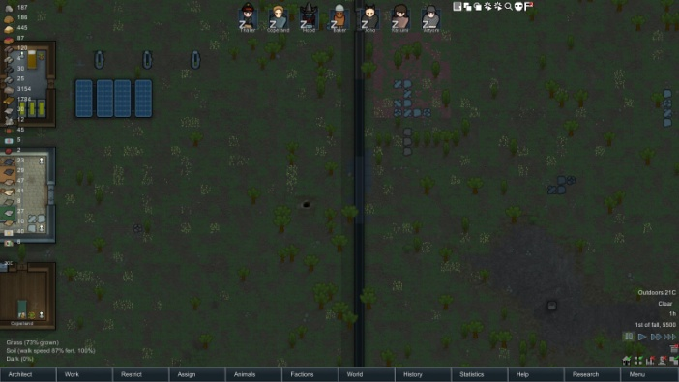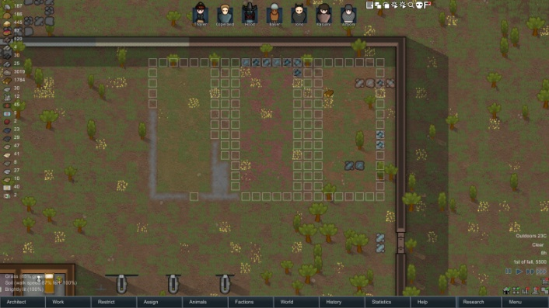

**Lance Baker’s Personal Journal**

**Entry 2, 2nd of Fall, 5500**

Progress continued at a decent pace. A manhunting pack of boomrats arrived; we barricaded the doors and prepared to hold inside. Later in the day, another cargo pod crashed down from the sky. As the pod hit the ground tons of steel spilled out, seems to be our lucky day. Also we began to lay tile around the nearby geothermal vent. Since we are trapped inside our walls, we might as well improve the area. We’ve also begun laying out floor plans for our new main building while we expanded our main stockpile to accommodate the influx of new supplies.

**Lance Baker’s Personal Journal**

**Entry 3, 7th of Fall, 5500**

The last few days have gone by without any trouble. We started on part of the Beer hall and finished up a full house: two bedrooms, a kitchen, and living room. Not much, but hey, it feels closer to home. We have some visitors coming in today from one of the nearby tribal groups, funny how they are friendly even though they are mostly incoherent. After some nice visitation, (I wish I understood them) we prepared to tear down a section of the walls and expand it out, very risky, but hey we have the material for it.

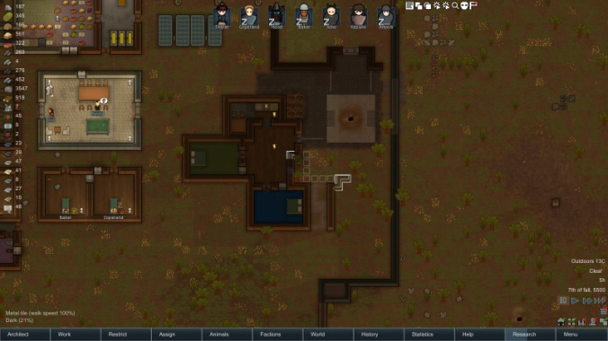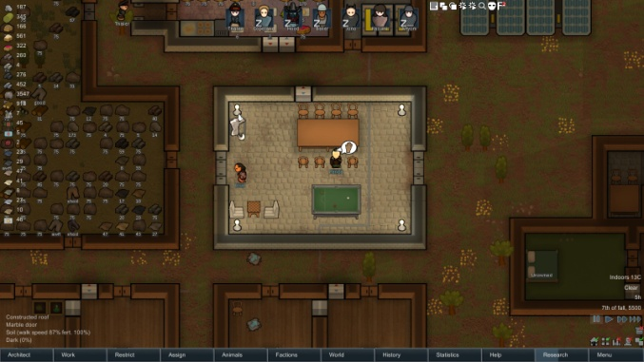

**Lance Baker’s Personal Journal**

**Entry 4, 9th of Fall, 5500**

Besides the occasional visitor, we have been uninterrupted in working on expanding the fortress. Hood finished his project just as most of us finished our lunch, geothermal power, the main point of our fort will be powered by the single geothermal pit we have started to expand around. Cheers and fanfare filled the settlement as we started laying out resources to construct it. The celebration was cut short though as Thaler and Copeland really got into it. The rest of us are not sure what happened, but blood was all over the site of our beer hall and both parties didn’t want to talk about what had occurred.

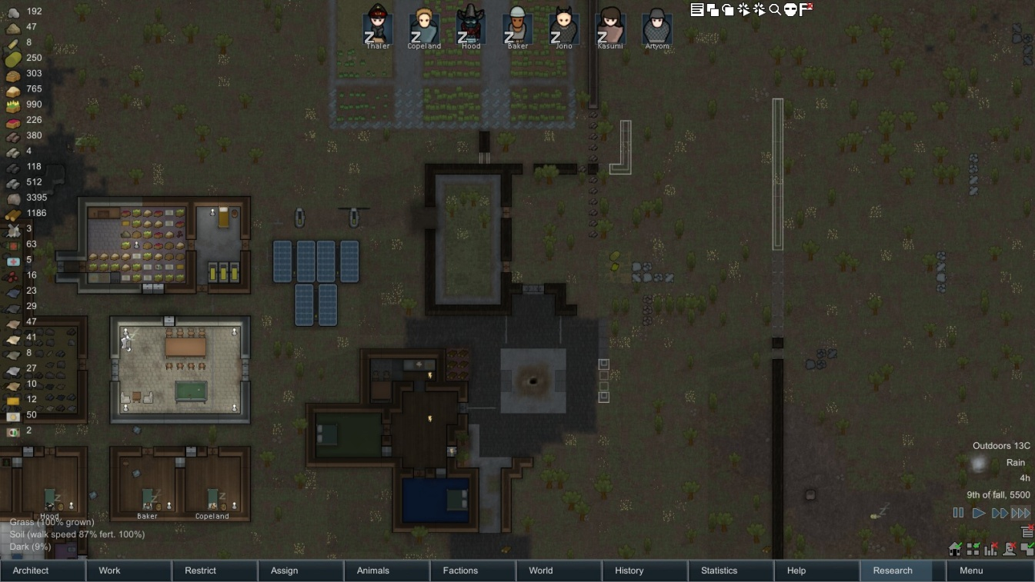

**Lance Baker’s Personal Journal**

**Entry 5, 12th of Fall, 5500**

This morning we awoke to find a traveling trader approaching the city. While the good he carried where mostly useless to us, the company was nice. Kasumi and Arytom have come together and formed a new relationship, the first to grace this place since founding. They happily moved into one of the new rooms of the house we built a few days back. We also started construction of the leaders houses and treasury reserve room. We decided that the leader will have access to the house with the treasury. We also decided that during that persons lead, only they will be used for trade.

**Lance Baker’s Personal Journal**

**Entry 6, 15th of Fall, 5500**

In the early morning hours of the last day of fall, we discovered Artyom was very ill. Malaria was our best assumption. We placed him into a bed and hoped the medicine we had would be enough to save him. I assisted with our daily tasked before taking a walk among the area I had improved. We had hops growing; however, they would not produce beer until after my leadership was over.

